CONFIGURE THE MOBILE APP FOR CONTROLLING

MOTOR USING BUTTONS

TEAM ID : PNT2022TMID41407

CONTROL DC MOTOR:

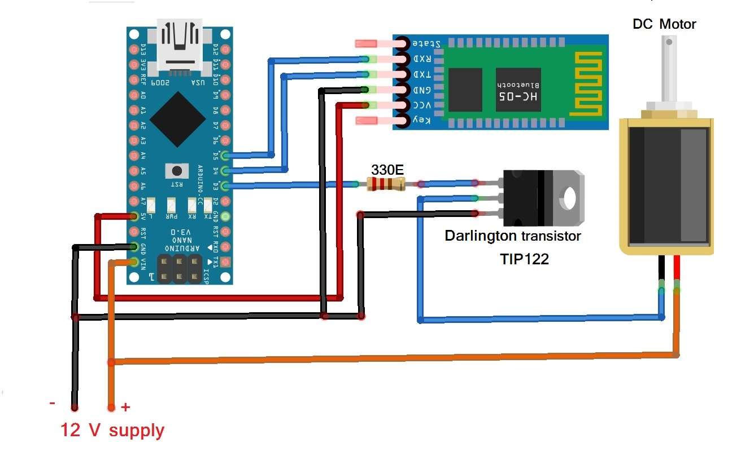

CONTROL SERVO MOTOR:

